Review this website: https://private-stock.lovable.app. On the new website, I want you to use the same header text font and size but change the text/buttons to “BRANDS STORE LOCATOR YOUR REWARDS LOGIN ICON CART ICON”. The text should be white but also dynamic, so it switches to black automatically when that would create a better contrast with the background image color(s) behind it. Similar to how this webpage operates, I want there to be a main hero image, but I want it to switch to a different image based on a hover over the header text and staying over it or staying over the new hero image it changed to (don’t add arrows to manually switch between the images) – allow me to upload videos instead of images also. Add a nice animation of the text being underlined, also similar to the webpage.
Remove the white padding on the top header so that the image is flush with the top of the screen with the header text right justified and visible on top of the image (see example below).
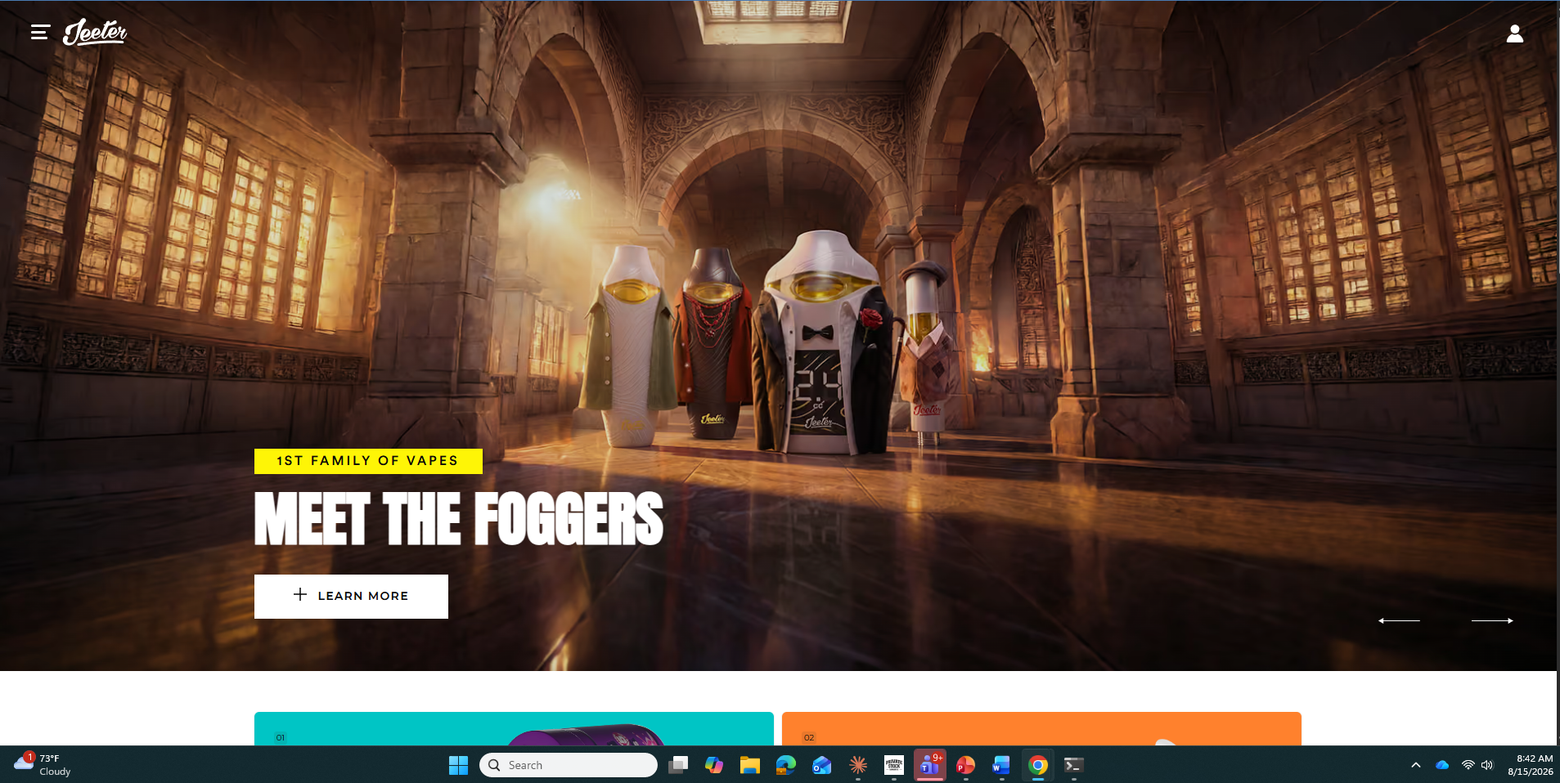
Left justified, I want to add a hamburger and the Private Stock logo (similar to the one above but make the logo larger like the size in my reference website link). These should also be white but dynamic also to change to black automatically when it would create a better contrast and be more readable based on the background. Pull the logo file for all my brands as needed from these google drive folders: https://drive.google.com/drive/folders/1N1qEKRrPmFlDblTyICDRdbJk6cadap1h?usp=sharing https://drive.google.com/drive/folders/15EyQOieLWhhpm1uVVh0adJDyC12af3sJ?usp=sharing https://drive.google.com/drive/folders/13BsofxAUn6pHjJi0JHDf9ePsMHKJjnog?usp=sharing https://drive.google.com/drive/folders/1L7myi1sARQpYJuozOKQNvgoBIPKk7bhu?usp=sharing https://drive.google.com/drive/folders/1K_wCbVdoXpIGzwM0Cuiszd3VfMWYEjRz?usp=sharing
When you click on the hamburger on the top left header, I want it to open up like this image below but with the following text buttons going downward: HOME, ABOUT, PRODUCTS , APPAREL, REWARDS, CONTACT
I want to build each of these out as separate pages.

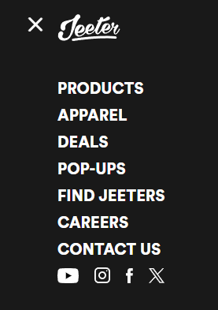

Below the hero image on the landing page, I want to add a rotating banner similar to the below example. This should be an automatic rotating banner which I can add a multiple graphics to the carousel (allow me to upload as videos also).


Below that, I want to add a short intro to our company section that includes this text and a placeholder for an image/video of cannabis:
A DEDICATION TO THE EXCEPTIONAL
Private Stock is defined by restraint, precision, and intention. As an owner-operator, we control every element to ensure integrity and consistency at scale, from cannabis cultivation to retail to community.
Excellence is not declared – it is demonstrated through uncompromising standards and attention to detail.
In this section, I also want to include our Product Catalog using the attached PDF, but I want to make is pop-out into a book format that has animations where the page flips when the user clicks and arrow on each page or drags the page with their finger or mouse.
Below this, I want a section that looks exactly like this next section of the https://private-stock.lovable.app page below:
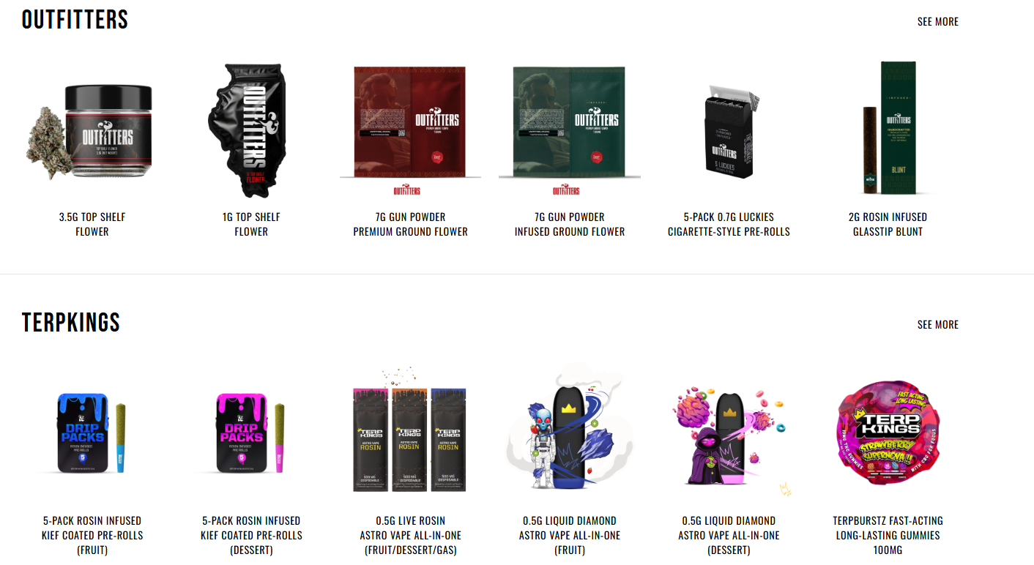
When a user clicks the brand name (reference image above), it should take them to the brand page. I want to create a brand page for each of the brands that looks exactly like these reference websites that I built previously: Outfitters (https://www.outfittersoriginal.com/), TerpKings (TBD), Higher Self (https://www.findhigherself.com/), and Savage Squad Strains (https://www.savagesquadstrains.com/). I’m going to forward these domains to our new subpages built here on the website when we’re done. The sub-pages don’t need to be age-gated if they are accessed from the main page. However, If they are accessed directly (or forwarded from the domain), they should have their own age gate similar to what they have. Do the same for their Newsletter pop-up for a 15% discount on merch and apparel (note that this can only be used once per customer and not with any other promotion code). The main website needs an age-gate pop-up and cookies along with a similar Newsletter pop-up.
I like the zoom effect on the product images on the hover (but also add a click for more info prompt on hover, but I also want to a dedicated page to open when clicked (this is to help with SEO). Below is an example of a layout for the pop-up. But it should add the following sections to the text side: Terpene Profile with dominant 2-3 terpenes, Description (take the image and description from the same spreadsheet that the PS Management app references for images for the Online Menu Checks function), More from “Brand” (when clicked takes you to the brand page). Change the Find In Stores button to a “Buy Now at the Below Locations” section and add a list of the Dispensary Names and their address that currently have that product on their menu. Add a See Menu button for each that when clicked, opens a new page to their menu for that specific product. Make a click on the dispensary’s name do the same. The information for where the product can be found should come from the same database as the Online Menu Checks from the PS Management app and automatically updated. To the right of the list of the dispensaries, add a visual showing a map of the region that includes all the locations, with hover and click options for each dispensary location marked on the map.
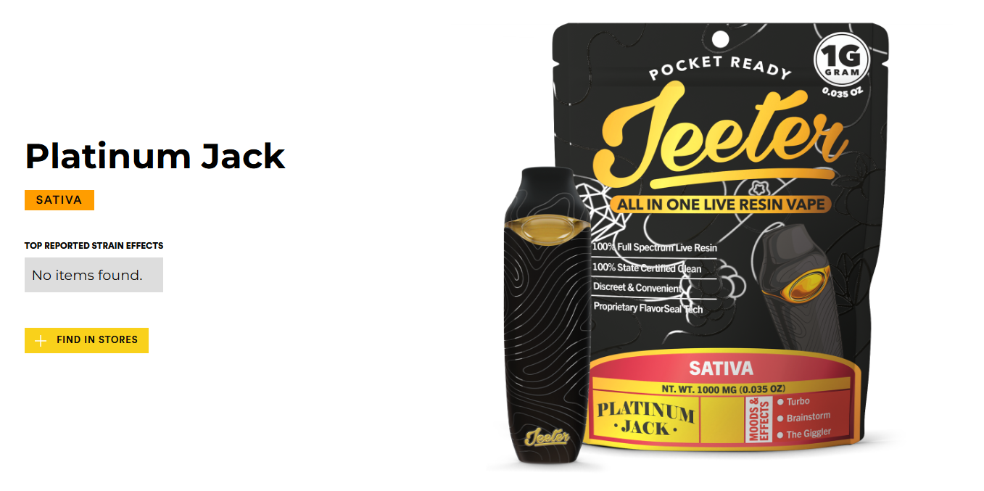
For the Apparel & Accessories section, I want to build a full shopping and payment experience using Stripe and Paypal (give me any other options there are). 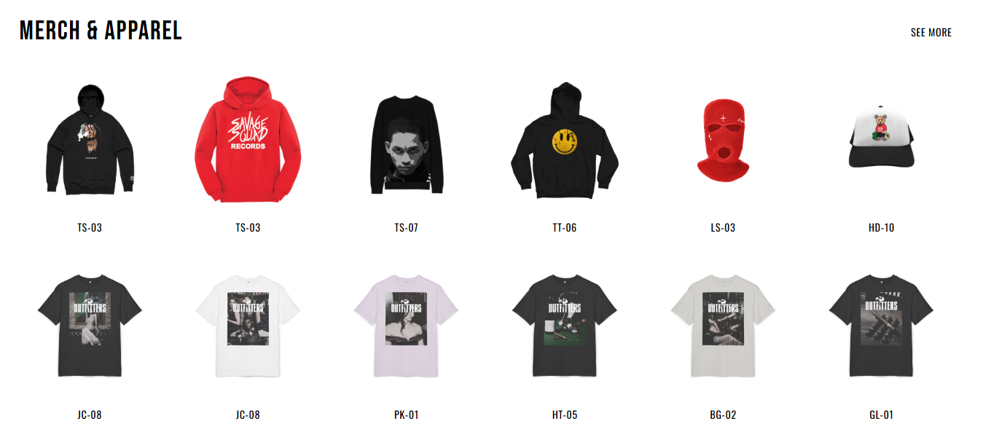
I need a full backed built to add products, photos, sizes, descriptions ect, as well as to manage the tracking of payments, customers, and fulfillment. I’m going to take payment, then use multiple white-label companies (like Printify and Tapstitch) to order and direct ship to the customer. The See More button will take the user to a new Apparel & Accessories page that I want to build out using this reference website: https://jeeterapparel.com/ Note – I don’t want any banners for any of the pages on this website (Like the one on this reference page or the savagesquadstrains.com website to be at the top of the page, move them directly below the hero image instead). Also for all pages on my website, I don’t want to change from the header structure with the hamburger and Private Stock logo on the left and the “STORE LOCATOR YOUR REWARDS LOGIN ICON CART ICON” on the right. All hero images for all sub pages, brand pages, etc should have the same look as the main landing page with them going all the way up to the top of the screen with the header text, logo, hamburger overlaying the image.
Below this section of the landing page, I want to add a new cool looking “In the News” section with a few blogs posts (image and short description with a read more button). When you click read more it opens a dedicated page for that post (to help with SEO). There should be a See More button for this section that take the user to a dedicated “In the News” page with all the current and historical blog posts for users to view (each post has its own page that opens up to help with SEO).
Below this section, add a FOLLOW US section that looks like this structure for the buttons with a scrolling set of images that I can add (Ignore the style of the image below, I want to keep my own style and just use the framework/structure). The only add buttons for Instagram and Facebook.
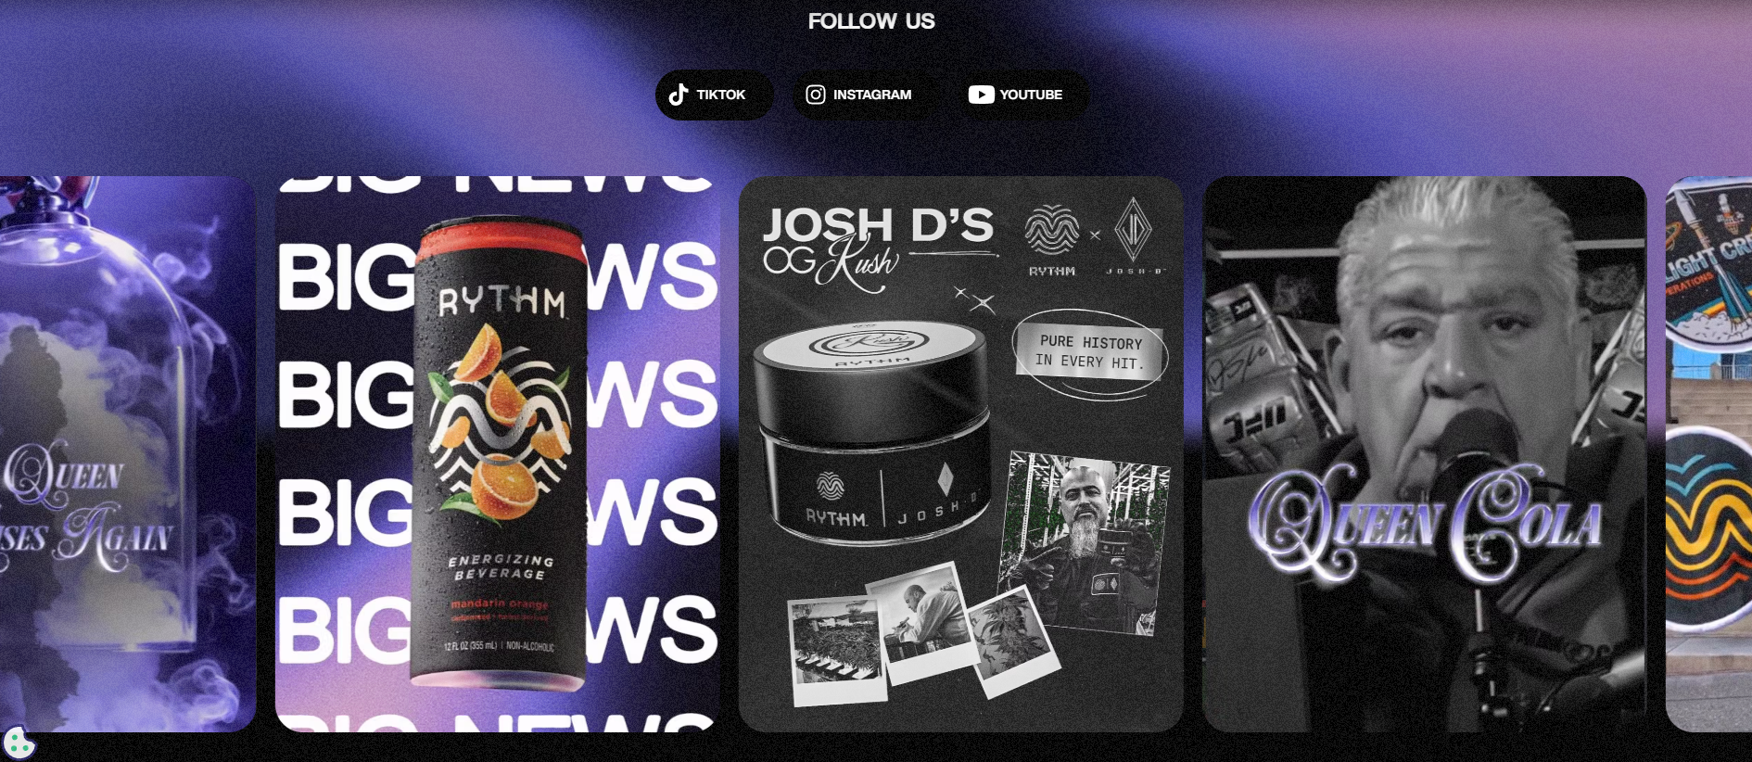
Below this section, add a Newsletter Sign-up section that is structured similar to this:
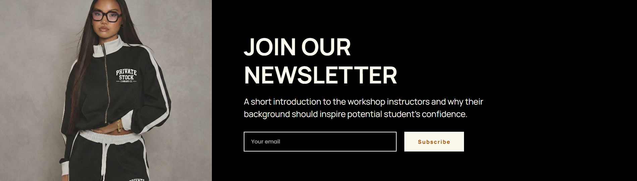
Lastly add the footer with all the normal footer sections you’d have for a robust website like this.
Help me build this out so there is a development and a production page. This way all future changes and updates can be pushed to dev branch and reviewed before pushing to production.

